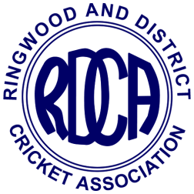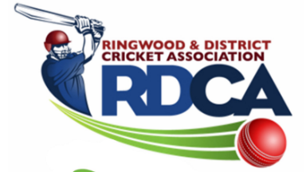

RINGWOOD AND DISTRICT CRICKET ASSOCIATION INC. (A0110509M)

CRICKET BALL ORDER FORM 2021/22 SEASON
Submit to Ian Spencer: Email – “rdca@sme.com.au”
• Balls to be ordered in multiples of 12, save for “Star” balls which is 6.
• Orders will be taken in last week of September, third week of November and second week of January.
ORDER DATE:
CLUB NAME: PERSON ORDERING:

BRAND OF BALL | BALL PRICE | QUANTITY ORDERED  (MULTIPLES OF 12) | TOTAL
TUF PITCH (156g) | $48.00
RED KING (156g) | $39.00
KOOKA COLT (156g) RED | $32.00
KOOKA COLT (142g) RED | $32.00
KOOKA COLT (142g) PINK | $36.00
KOOKA SPECIAL TEST  WHITE (156gm) | $49.00
STAR BALL  For Mini Bash and lower levels of girls competitions  (In boxes of 6) | $12.00
$

TOTAL AMOUNT PAYABLE
Note:
• Payment must be made at time of collection (cheque) or be prepaid by EFT.
• Discount of 3% will be paid to clubs in due course when balls are collected and paid for within 7 days of contact person(s) being notified that they are available.
• Club will incur a fine of 5% of total payable if balls are not paid for within 14 days of being notified they are
available.

