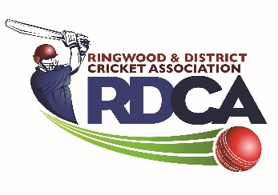
RDCA 2019/2020 Award Nominations

Please fill out the following Nominations for this years Awards Presented on the Jr RDCA Presentation Night Thursday 26th March.

Jeff Luscombe Junior Volunteer of the Year Award

Please provide details of the name of the nominated recipient and as much detail as possible to justify them being awarded this award below or attach a separate letter.

Bill Dean Memorial Trophy/Most Promising Player Leaving Under 16’s

Please provide details of the name of the nominated recipient and as much detail as possible to justify them being awarded this award or attach a separate letter.

Harry Flynn
North Ringwood Cricket Club
All-Rounder
2020 Stats:
- 428 Runs at 107 average - Including one century and two half centuries (Left hand bat)
- 16 Wickets at 9.44 average (Left Arm Fast)

Other Achievements:
- Represented Victoria at 15 and Under level
- Made 1st 11 debut for Bayswater and has taken 7 wickets at 19.86 and made 86 runs at 17.2
- 2nd 11 stats – 155 runs at 31 and 6 wickets at 26.17
- Represented Outer East Eagles in the YPL and made 154 runs at 19.25 and took 13 wickets at 13.38
  - Captain of winning team.
- Over 1030 runs for the season in all competitions at 36.96
- 47 wickets at 16.30 for the season across all competitions with a best of 5/19.
- Whilst a Junior he played 252 matches (Junior & Senior combined), scored 4863 runs at 30.78 and took 227 wickets at 14.72 plus effecting 27 run outs and taking 102 catches.

Harry is a terrific clubman and has been captain on a number of occasions. He is polite, respectful and enthusiastic at all times and leads by example with his terrific work ethic. He has volunteered a couple of times a year whilst in both years at U/16 level with our Woolworths cricket kids. Harry can often be seen outside of training working on his game, a fair effort given he already trains with his Under 16 team, his YPL team and Bayswater’s senior teams.
We are delighted to be able to nominate Harry for this award and commend him as a worthy recipient.

Failure to complete this form correctly may see a member of you club miss out on an award they deserve.
Please return this to the RDCA Junior Secretary Mandy Dolman dolman7@bigpond.com no later than Monday 16th March 2020

